Author: Adrian Szklarski, 16.06.2022.
Technological level: Advanced
Programming level: Mid
Technologies used: Python 3.10 | PyCharm | Linux | OpenOffice

Description of the problem: An unidentified flying object „NOL” (a black triangle with three lights underneath) flies at the height of the trees in the evening sky moving from the observer to point A then to point B and flies away in the direction of Orion's Belt, so let's play with NOL for a while :D let's take a look at Area 51 what they are doing there ;). For this you will need a drawing:
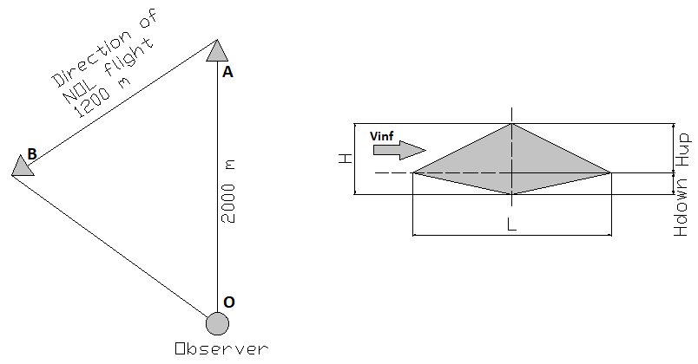

Indicative data:
1. The distance AB on the horizon when the line is plotted on the maps is about:
2. Flight time between AB points not more than:
3. Speed from classical mechanics without going into scientific detail is:
5. Length of the longitudinal axis of the object:
4. Let's assume that it is July, around 9 p.m. and the day is very warm so the temperature was within which gives the speed of sound in air:
Wave drag is a phenomenon referred to as an additional pressure drag force that occurs at subsonic speeds above a critical velocity and at supersonic speeds, where a step change in pressure near a particular moving object becomes apparent. This additional force is directed in the direction opposite to the direction of flight.
We will determine the coefficient of resistance of the NOL to its chord, for a given velocity Ma, the object was flying at one height so we will assume the angle . Suppose that and .

Thus:
wave resistance factor where:

Similarly for the bottom part:
finally

Code:
import math

class NOL:

def __init__(self, AB, t, T, L):
self.AB = AB
self.t = t
self.T = T
self.L = L

def Mach(self):
tab_of_speed = [306.5, 312.9, 319.3, 325.6, 331.8, 337.8, 340.3, 343.8, 349.6, 355.3]
indx = tab_of_temp.index(self.T)
ind = tab_of_speed.pop(indx)
self.mach = (self.AB/self.t)/ind
return round(self.mach, 2)

def cxP(self):
h_down = 0.01 * self.L
self.h_up = 2 * h_down
a = h_down/self.L
self.cx_prim = 40*((math.pow(a, 2))/math.sqrt(math.pow(nol.Mach(), 2)-1))
return round(self.cx_prim, 8), self.h_up

def __str__(self):
return f'{self.mach}, {self.cx_prim}'

if __name__ == '__main__':
tab_of_temp = [-40, -30, -20, -10, 0, 10, 20, 30, 40]
while True:
try:
AB = float(input('Enter flight distance [m]: '))
t = float(input('Enter flight time [s]: '))
L = float(input('Specify the length of the NOL height [m]: '))
T = int(input('choose the air temperature from the list: \n\
-40, -30, -20, -10, 0, 10, 20, 30, 40: '))
a = [element for element in tab_of_temp if T == element]
if a:
nol = NOL(AB, t, T, L)
print("Mach:", nol.Mach(), "cx': ", nol.cxP()[0])
break
except ValueError:
print('You have entered a value from outside the table, try again')
